**BANK APPLICATION SCREENSHOTS**

**Types:** There are three types of users for this application.

1. Admin.
2. Manager.
3. Clerk.

**Users and their roles:**

1. Admin: Among all the users, Admin can perform all actions on an account. Th actions include creating new account, create new user for the application, Suspend a account and delete a account.
2. Manager: Manager is also an user who has limited actions. The actions include update account, Transfer fund that require approval.
3. Clerk: Clerk is the low tier user who can only perform action fund transfer and get transaction history.

**Actions:**

1. **Login**: This is used to login for particular person. It takes parameters like username and password. If login fails he/she will be redirected to home page.

**Output:**

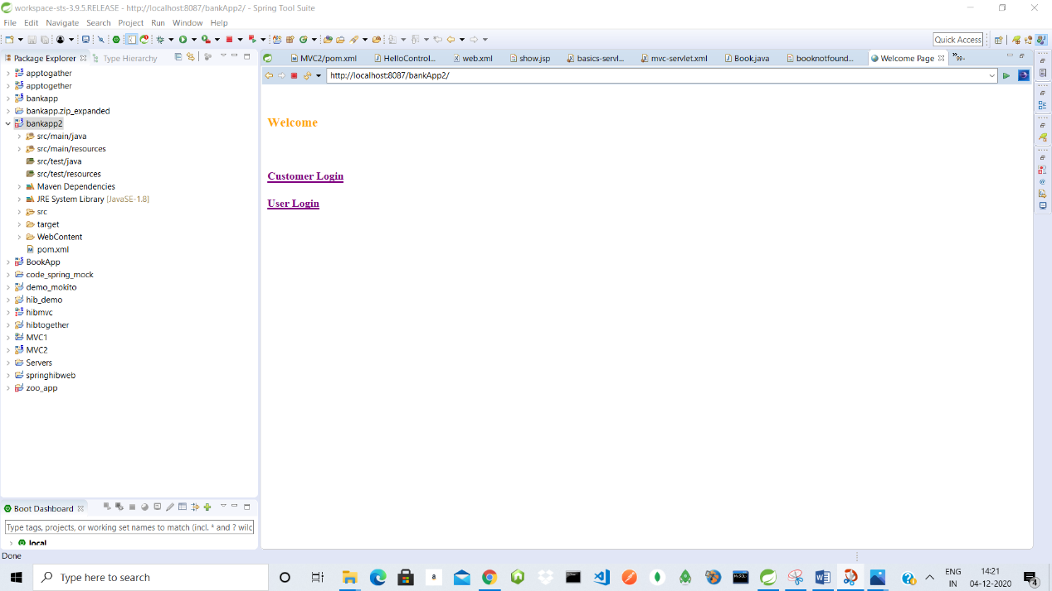

1. **AddUser**: This action allows us to add user. The inputs are username, password, user type, address, phone number, email, aadhar card and pan card.

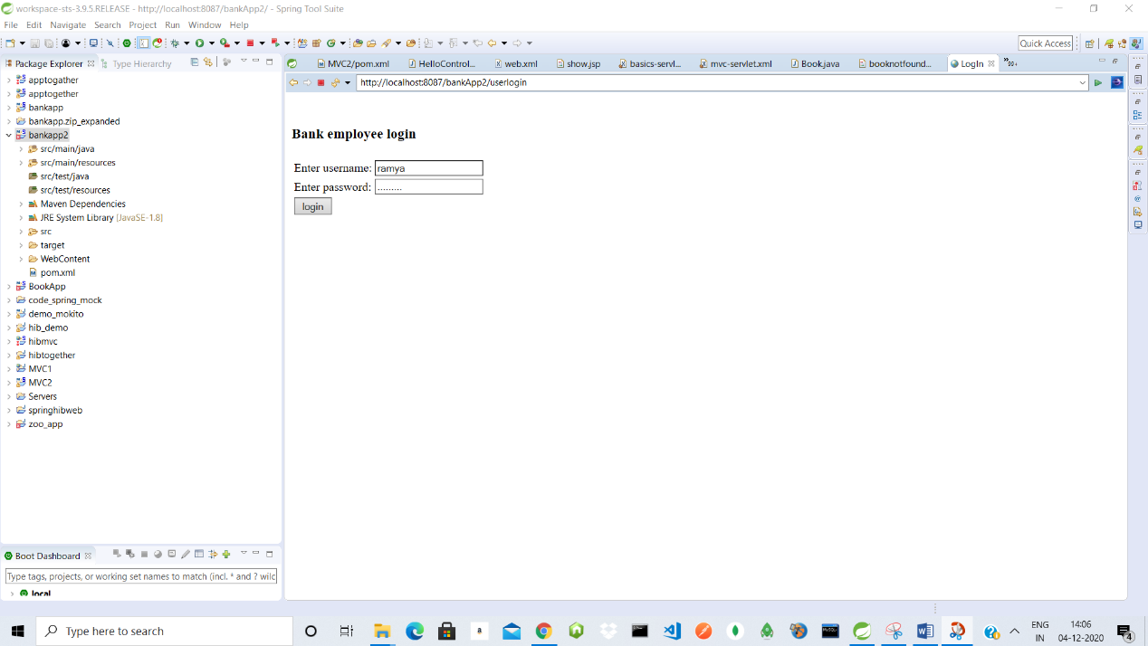

1. **Deposit:** This action allows us to deposit money in user account. It takes parameters like account number and amount to be deposited.

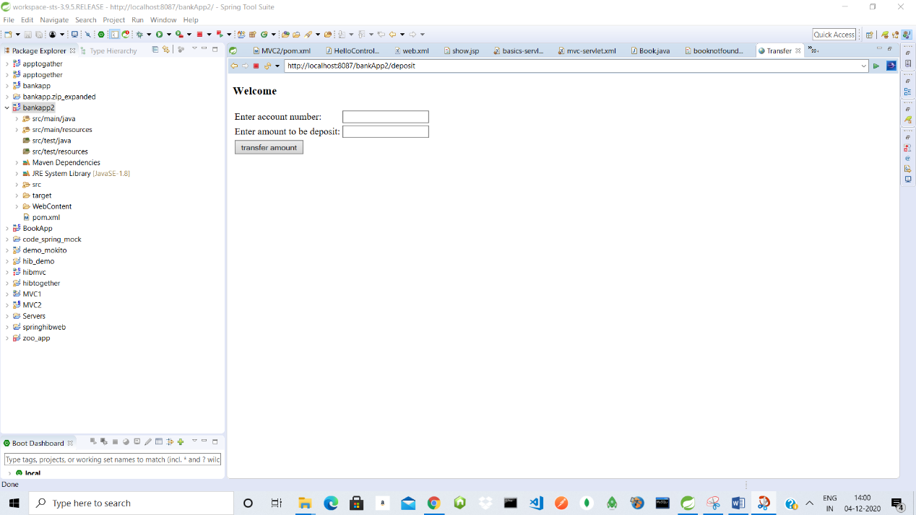

1. **Withdraw:** This action allows the user to withdraw money from his account. It takes two parameters like account number and amount to withdraw.

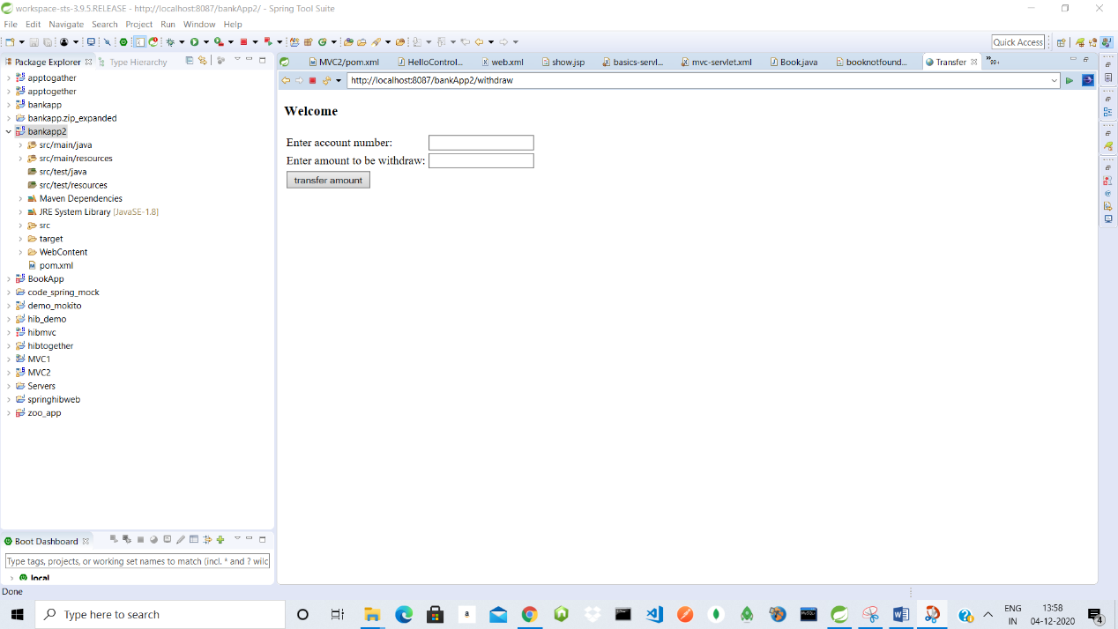

1. **Fund Transfer:** This action allows an user to transfer fund from one account to another. It takes 3 parameters from account number, to account number and amount to transfer.
2. **AddAccount:** It is similar to add user but it takes an extra input called user type which indicates whether the user is an admin, manager or clerk.
3. **ShowAllAccounts:** Show all accounts is used to display all the accounts in the accounts table.
4. **ShowAllUsers:** Show all users is used to display all the users in the users table which include admin, manager or clerk.
5. **UpdateAccount/UpdateUser:** Used to update details for an user or an account.

**Validations:**

**Account number:** Account number is validated by checking whether it is already existing in database or not.

**Withdraw:** The amount for withdraw will also be validated since it should always be less than the current balance.

**Fund Transfer:** Fund transfer also requires validation for both account numbers and money to be transferred.

* Validations also include not null(which indicates that the details should be filled), should enter number(should enter number only), should enter string(should enter string only) etc.

**Updating User/Account:**

While updating user/account only specific data can be updated. The data are Address, Phone and Email.

**Output:**

